WEEK 2

Mandatory Hands-On

**PL/ SQL Programming**

**EX:3 Stored Procedures**

**Scenario 1: The bank needs to process monthly interest for all savings accounts.**

**PL/ SQL QUERY:**

CREATE PROCEDURE ProcessMonthlyInterest

IS

BEGIN

UPDATE Accounts

SET Balance = Balance + (Balance * 0.01),

LastModified = SYSDATE

WHERE AccountType = 'Savings';

DBMS_OUTPUT.PUT_LINE('Monthly interest applied to all savings accounts.');

END;

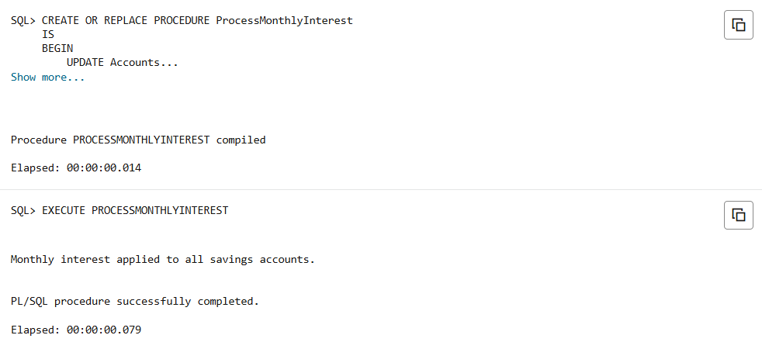**OUTPUT:**

**Scenario 2: The bank wants to implement a bonus scheme for employees based on their performance.**

**PL/ SQL QUERY:**

CREATE PROCEDURE UpdateEmployeeBonus (

p_department IN VARCHAR2,

p_bonus_pct IN NUMBER

)

IS

BEGIN

UPDATE Employees

SET Salary = Salary + (Salary * p_bonus_pct / 100)

WHERE Department = p_department;

DBMS_OUTPUT.PUT_LINE('Bonus updated for department: ' || p_department);

END;

**OUTPUT:**

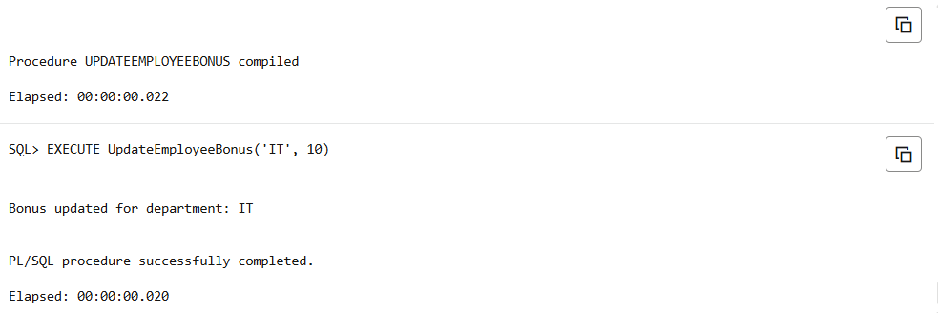

**Scenario 3: Customers should be able to transfer funds between their accounts.**

**PL/ SQL QUERY:**

CREATE OR REPLACE PROCEDURE TransferFunds (

p_from_account IN NUMBER,

p_to_account IN NUMBER,

p_amount IN NUMBER

)

IS

v_from_balance NUMBER;

BEGIN

SELECT Balance INTO v_from_balance

FROM Accounts

WHERE AccountID = p_from_account;

IF v_from_balance < p_amount THEN

DBMS_OUTPUT.PUT_LINE('Transfer failed: Not enough balance.');

RETURN;

END IF;

UPDATE Accounts

SET Balance = Balance - p_amount,

LastModified = SYSDATE

WHERE AccountID = p_from_account;

UPDATE Accounts

SET Balance = Balance + p_amount,

LastModified = SYSDATE

WHERE AccountID = p_to_account;

DBMS_OUTPUT.PUT_LINE('Transfer of ' || p_amount || ' completed from Account ' ||

p_from_account || ' to Account ' || p_to_account);

END;

**OUTPUT:**

